Green Mountain Reservoir and Lake Dillon Monitoring Project

2017 Annual Report

Prepared by:
William M. Lewis, Jr.
James H. McCutchan, Jr.
Jennifer Roberson
April 23, 2018

Rpt397
Introduction
This report summarizes the results of water quality monitoring supported by the Summit Water Quality Committee in calendar year 2017. It provides an overview of the results for the year and gives comparisons with previous years.

Monitoring Plan
Lake Dillon was sampled on 6 dates, Green Mountain Reservoir was sampled on 10 dates, and the watershed sites were sampled on 18 dates during 2017 (Table 1). Samples were taken throughout the year, but sampling was most frequent for streams during the runoff months and most frequent for lakes during the growing season because of the greater importance of these months to the calculation of loading rates and trophic status indicators.
Dillon | Green Mountain | Green Mountain Watershed
6/27/17 | 6/15/17 | 1/19/17
7/18/17 | 6/29/17 | 2/16/17
8/1/17 | 7/13/17 | 3/9/17
8/22/17 | 7/27/17 | 4/13/17
9/18/17 | 8/10/17 | 5/11/17
10/10/17 | 8/24/17 | 5/25/17
 | 9/14/17 | 6/15/17
 | 9/28/17 | 6/29/17
 | 10/19/17 | 7/13/17
 | 11/9/17 | 7/27/17
 |  | 8/10/17
 |  | 8/24/17
 |  | 9/14/17
 |  | 9/28/17
 |  | 10/11/17
 |  | 10/19/17
 |  | 11/9/17
 |  | 12/7/17

Table 1. Summary of sampling dates for 2017.

Over the last 19 years, the Summit Water Quality Committee has alternated its emphasis on Lake Dillon and Green Mountain Reservoir. In years of emphasis on Green Mountain Reservoir, Lake Dillon has been monitored only monthly, and for a reduced set of variables and no watershed sampling. The year 2017 was designated for focus on Green Mountain Reservoir. Therefore, a full set of lake and watershed monitoring was planned and executed for Green Mountain Reservoir. The Blue River water supply to Green Mountain Reservoir was also sampled upstream of the reservoir.
This report also includes data on Lake Dillon, even though the main emphasis is on Green Mountain Reservoir. The data on Lake Dillon are less comprehensive than in years for which Lake Dillon is the main focus. The reason for sampling Lake Dillon in years of focus on Green Mountain is to provide continuous interannual data on Dillon for water quality because of unusual conditions that occurred in 2002 and 2004.
In 2005 the CDPHE Water Quality Control Division notified the Summit Water Quality Committee that Lake Dillon was being considered for 303d listing as either impaired or requiring monitoring. The reason for the listing was exceedance of the phosphorus standard in 2002 and 2004. The exceedances were caused by extraordinarily low reservoir inflows and not by increased water pollution, as shown by the SWQC data record. Even so, strict interpretation of the rules of the State by based on EPA mandated reporting suggested that some type of listing was needed. The State listed Lake Dillon as requiring monitoring, but not as impaired. Therefore, the monitoring for phosphorus and chlorophyll became even more important for Lake Dillon than it had been previously. The present report contains, in addition to detailed information on Green Mountain Reservoir, information on water quality for Lake Dillon as needed to show compliance with water quality standards. The State decided that Lake Dillon need not be listed as impaired on the basis of conditions in 2002 and 2004, but a continuous record is needed to show compliance with standards.
Green Mountain Reservoir was sampled at four stations: the index station (Figure 1) and three other stations evenly spaced upstream from the index station (GA closest to inflow, GB next, and GC closest to index station). One station (index station, over deepest water) was sampled on Lake Dillon (Figure 1).
The watershed sampling sites for Green Mountain included the Blue River at its exit from Lake Dillon, the water flowing into and out of Green Mountain Reservoir, Silverthorne/Dillon WWTF, Straight Creek near its confluence with the Blue River, and the Blue River between Silverthorne and Green Mountain Reservoir (Figure 1, Table 2). Lake Dillon was sampled at the index station near the dam.
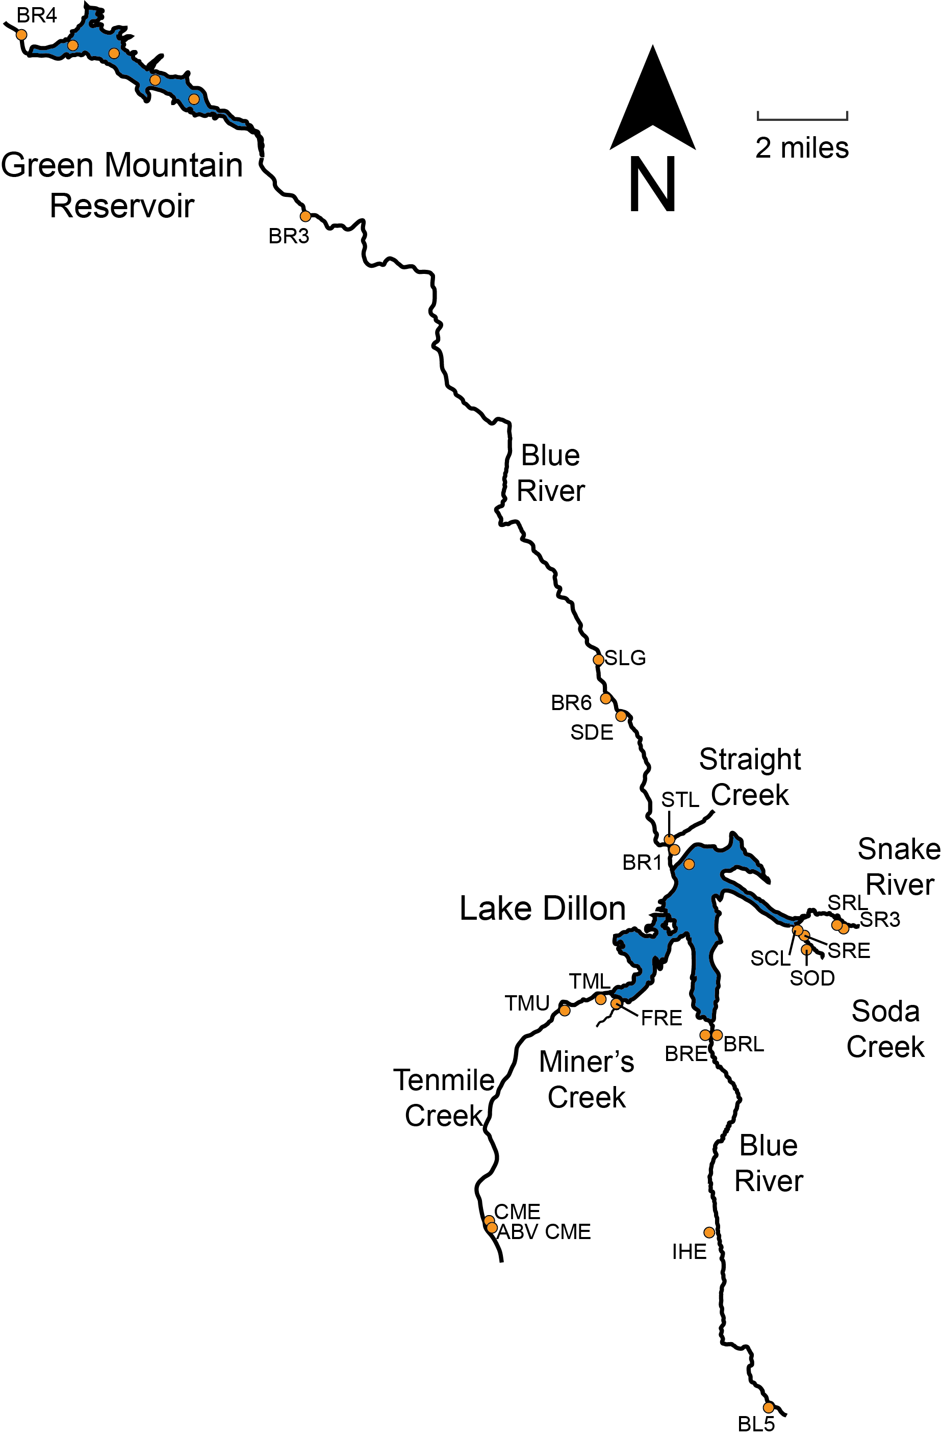
Figure 1. Location map for sampling, 2017.
Code | Description of Site
BR4 | Blue River at outlet from Green Mountain Reservoir
BR3 | Blue River at the inlet to Green Mountain Reservoir
BR6 | Blue River below Silverthorne, upstream from Bushee Creek.
STL | Straight Creek above confluence with Blue River
BR1 | Blue River at outlet from Dillon Reservoir.
SDE | Silverthorne/Dillon effluent (labeled Silv Eff in 1996)
Table 2. Location of sampling stations, 2017.

Methods
Table 3 summarizes the analytical coverage for the lake and watershed sampling. The methods used in 2017 were similar to those used in previous years.
Variable | Lake Index Station | Other Lake Stations | Stream Stations
Temperature | + | + | +
Transparency | + | +
Discharge |  |  | +
Conductance | + | + | +
Nitrate | + | + | +
Soluble Reactive P | + | + | +
Total Soluble P | + | + | +
Particulate P | + | + | +
Total P | + | + | +
Total Suspended Solids | + | + | +
Chlorophyll a | + | +
Dissolved Oxygen | + | +
Total N | + |  | +
Algal Abundance (counts) | +
Table 3. Summary of analytical coverage for different kinds of samples.

Results
Hydrology
Water surface elevations, inflows, and outflows are summarized in Table 4 (Lake Dillon) and Table 5 (Green Mountain Reservoir). The source of the information for Lake Dillon was the Denver Water Department; the source of the information for Green Mountain Reservoir was the Bureau of Reclamation.
Month | Mid-Month Elevation (ft) | Inflow, AF | Blue River Outflow, AF | Roberts Tunnel, AF | Total Outflow, AF
Jan | 9008 | 6133 | 5533 | 4957 | 10589
Feb | 9006 | 5091 | 5440 | 5082 | 10522
Mar | 9004 | 7578 | 4982 | 7111 | 12092
Apr | 9004 | 14900 | 5660 | 7763 | 13424
May | 9006 | 35590 | 12894 | 5599 | 18493
Jun | 9016 | 87704 | 52962 | 11248 | 64211
Jul | 9018 | 32373 | 19005 | 13105 | 32110
Aug | 9018 | 14525 | 12880 | 7329 | 20209
Sep | 9014 | 9426 | 6256 | 11855 | 18111
Oct | 9014 | 8900 | 6181 | 202 | 6383
Nov | 9014 | 6089 | 7424 | 0 | 7553
Dec | 9013 | 4884 | 6313 | 0 | 6648
Total |  | 233193 | 145530 | 74251 | 220345
Monthly Average |  | 19433 | 12128 | 6188 | 18362

Table 4. Elevation, computed inflow, and outflow for Lake Dillon (2017).

Month | Mid-Month Elevation (ft) | Inflow, AF | Total Outflow, AF
Jan | 7899 | 10218 | 15457
Feb | 7897 | 9974 | 11424
Mar | 7894 | 12283 | 14006
Apr | 7895 | 18651 | 12927
May | 7905 | 40158 | 18454
Jun | 7933 | 114133 | 53417
Jul | 7949 | 47521 | 44869
Aug | 7949 | 22862 | 35066
Sep | 7934 | 12423 | 46476
Oct | 7916 | 11847 | 39928
Nov | 7905 | 11055 | 14293
Dec | 7903 | 9270 | 12678
Total |  | 320395 | 318995
Monthly Average | 7915 | 26700 | 26583

Table 5. Elevation, computed inflow and outflow for Green Mountain Reservoir (2017).

For Lake Dillon, spillway overflow was in progress on January and continued through mid September. The total number of days (61) that water flowed over the spillway was 13th highest observed since 1981 (Table 6). Operation of Lake Dillon during 2017 resulted in a hydraulic residence time of 1.09 years based on outflow (Table 7), which is below the median (1.11 y).
Year | Days over spillway | Rank for spillway flow
1981 | 0 | 30
1982 | 119 | 1
1983 | 58 | 14
1984 | 0 | 30
1985 | 67 | 11
1986 | 104 | 2
1987 | 90 | 5
1988 | 43 | 20
1989 | 42 | 21
1990 | 38 | 24
1991 | 74 | 9
1992 | 42 | 21
1993 | 36 | 26
1994 | 27 | 29
1995 | 95 | 4
1996 | 56 | 16
1997 | 78 | 6
1998 | 78 | 6
1999 | 96 | 3
2000 | 57 | 15
2001 | 49 | 19
2002 | 0 | 30
2003 | 0 | 30
2004 | 0 | 30
2005 | 29 | 28
2006 | 42 | 21
2007 | 53 | 18
2008 | 56 | 16
2009 | 78 | 6
2010 | 67 | 11
2011 | 32 | 27
2012 | 0 | 30
2013 | 0 | 30
2014 | 0 | 30
2015 | 72 | 10
2016 | 37 | 25
2017 | 61 | 13

Table 6. Importance of spillway overflow since 1981, Lake Dillon.

Year | Surface Area, ha | Volume, 10⁶ m³ | Residence Time (Inflow), y | Residence Time (Outflow), y
1981 | 993 | 231 | 1.80 | 1.28
1982 | 1093 | 260 | 0.97 | 1.75
1983 | 1284 | 310 | 0.89 | 0.87
1984 | 1239 | 299 | 0.65 | 0.64
1985 | 1233 | 297 | 1.08 | 1.08
1986 | 1274 | 307 | 1.01 | 1.05
1987 | 1275 | 307 | 1.46 | 1.48
1988 | 1259 | 304 | 1.38 | 1.36
1989 | 1257 | 303 | 1.38 | 1.34
1990 | 1246 | 299 | 1.45 | 1.52
1991 | 1242 | 299 | 1.37 | 1.31
1992 | 1228 | 295 | 1.41 | 1.33
1993 | 1191 | 286 | 0.94 | 0.92
1994 | 1194 | 286 | 1.41 | 1.40
1995 | 1195 | 285 | 0.66 | 0.71
1996 | 1241 | 299 | 0.75 | 0.72
1997 | 1226 | 294 | 0.74 | 0.76
1998 | 1274 | 307 | 1.41 | 1.41
1999 | 1246 | 300 | 0.94 | 0.92
2000 | 1239 | 298 | 1.17 | 1.16
2001 | 1197 | 287 | 1.20 | 1.08
2002 | 939 | 219 | 1.86 | 1.06
2003 | 1019 | 241 | 0.90 | 1.47
2004 | 1151 | 275 | 1.89 | 1.68
2005 | 1187 | 284 | 1.43 | 1.68
2006 | 1252 | 302 | 1.08 | 1.11
2007 | 1273 | 306 | 1.09 | 1.09
2008 | 1251 | 297 | 0.98 | 0.95
2009 | 1249 | 300 | 0.96 | 0.99
2010 | 1246 | 299 | 1.29 | 1.16
2011 | 1205 | 289 | 0.67 | 0.71
2012 | 1161 | 277 | 2.15 | 1.36
2013 | 1107 | 264 | 1.12 | 1.68
2014 | 1160 | 297 | 0.80 | 0.82
2015 | 1275 | 307 | 0.98 | 0.93
2016 | 1275 | 302 | 1.20 | 1.16
2017 | 1230 | 296 | 1.03 | 1.09

Table 7. Summary of hydrologic statistics for Lake Dillon since 1981. Surface area and lake volume are averages based on daily values calculated from lake elevation.

As shown in Table 8, the hydraulic residence time for Green Mountain Reservoir in 2017 (0.30 y) was near the median residence time for all other years (0.32 for outflow). Green Mountain Reservoir always flushes more rapidly than Lake Dillon but loses much less water over the spillway than Lake Dillon. Water passes through the penstocks at an elevation of 7800 feet.

Year | Surface Area, ha | Volume, 10⁶ m³ | Residence Time (Inflow), y | Residence Time (Outflow), y
1985 | 676 | 136.5 | 0.25 | 0.25
1986 | 639 | 128.0 | 0.25 | 0.25
1987 | 643 | 127.0 | 0.40 | 0.38
1988 | 595 | 114.5 | 0.33 | 0.32
1989 | 594 | 114.8 | 0.41 | 0.41
1990 | 554 | 104.8 | 0.35 | 0.35
1991 | 640 | 127.5 | 0.39 | 0.46
1992 | 629 | 122.8 | 0.50 | 0.47
1993 | 669 | 134.7 | 0.33 | 0.37
1994
1995
1996
1997 | 700 | 143.1 | 0.23 | 0.24
1998
1999 | 639 | 126.4 | 0.27 | 0.29
2000
2001 | 550 | 103.4 | 0.38 | 0.43
2002
2003
2004
2005 | 647 | 128.3 | 0.43 | 0.46
2006
2007 | 657 | 129.8 | 0.32 | 0.31
2008
2009 | 611 | 119.7 | 0.23 | 0.24
2010
2011 | 631 | 124.8 | 0.19 | 0.20
2012
2013 | 596 | 114.0 | 0.44 | 0.52
2014
2015 | 620 | 122.0 | 0.24 | 0.24
2016
2017 | 601 | 116.7 | 0.30 | 0.30
Table 8. Summary of hydrologic statistics for Green Mountain Reservoir since 1985.

Temperature and Mixing

Lake Dillon was covered with ice from late December through early May. The epilimnion formed in late May and persisted into October, after which there was erosion of the thermocline leading to mixing after the middle of October (no sampling was done after October; Figure 2).

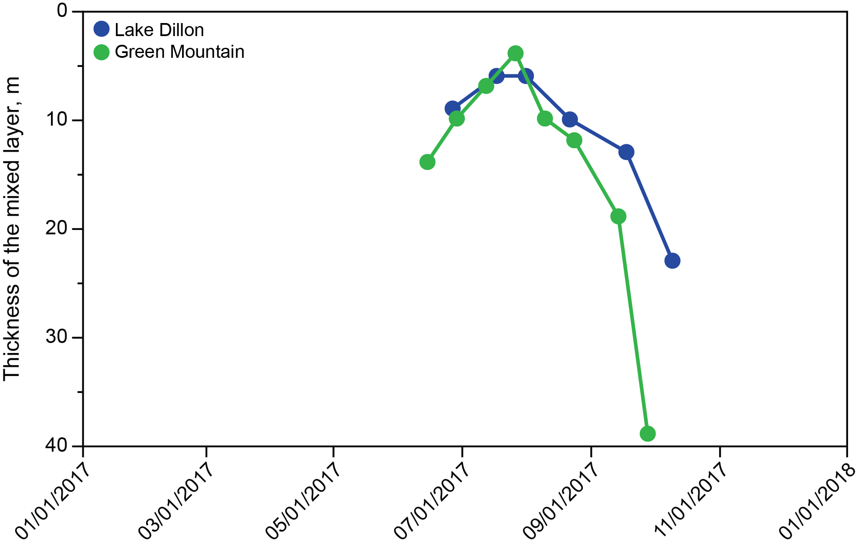
Figure 2. Thickness of the mixed layer, 2017.

Green Mountain Reservoir showed less well defined thermal layering than Lake Dillon because of large amounts of water withdrawal, but a mixed layer could be identified between the middle of June and late August (Figure 2). This is typical of Green Mountain Reservoir.

Transparency
Transparency of Lake Dillon and Green Mountain Reservoir was lowest in June-July (Figure 3), which is often the case because of high inorganic turbidity that enters the lake in spring, and in late fall coinciding with an algal biomass peak. Transparency was highest in winter and late summer, reflecting low algal abundance and low inorganic turbidity.
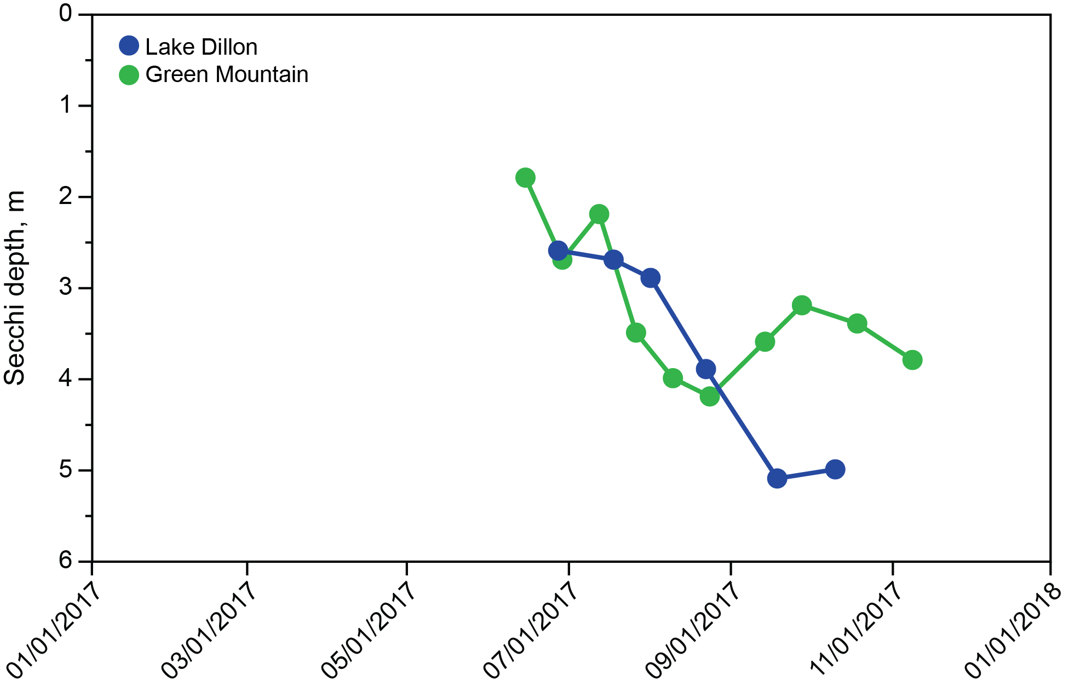
Figure 3. Transparency, 2017.
Phosphorus in the Lakes
Lake Dillon showed lower P concentrations than Green Mountain Reservoir during runoff in 2017 (Figure 4). Green Mountain Reservoir showed peak P concentration in June, during runoff. The higher total concentrations of P in spring for Green Mountain Reservoir, caused by mineral particles, have been typical in previous years of monitoring as well.

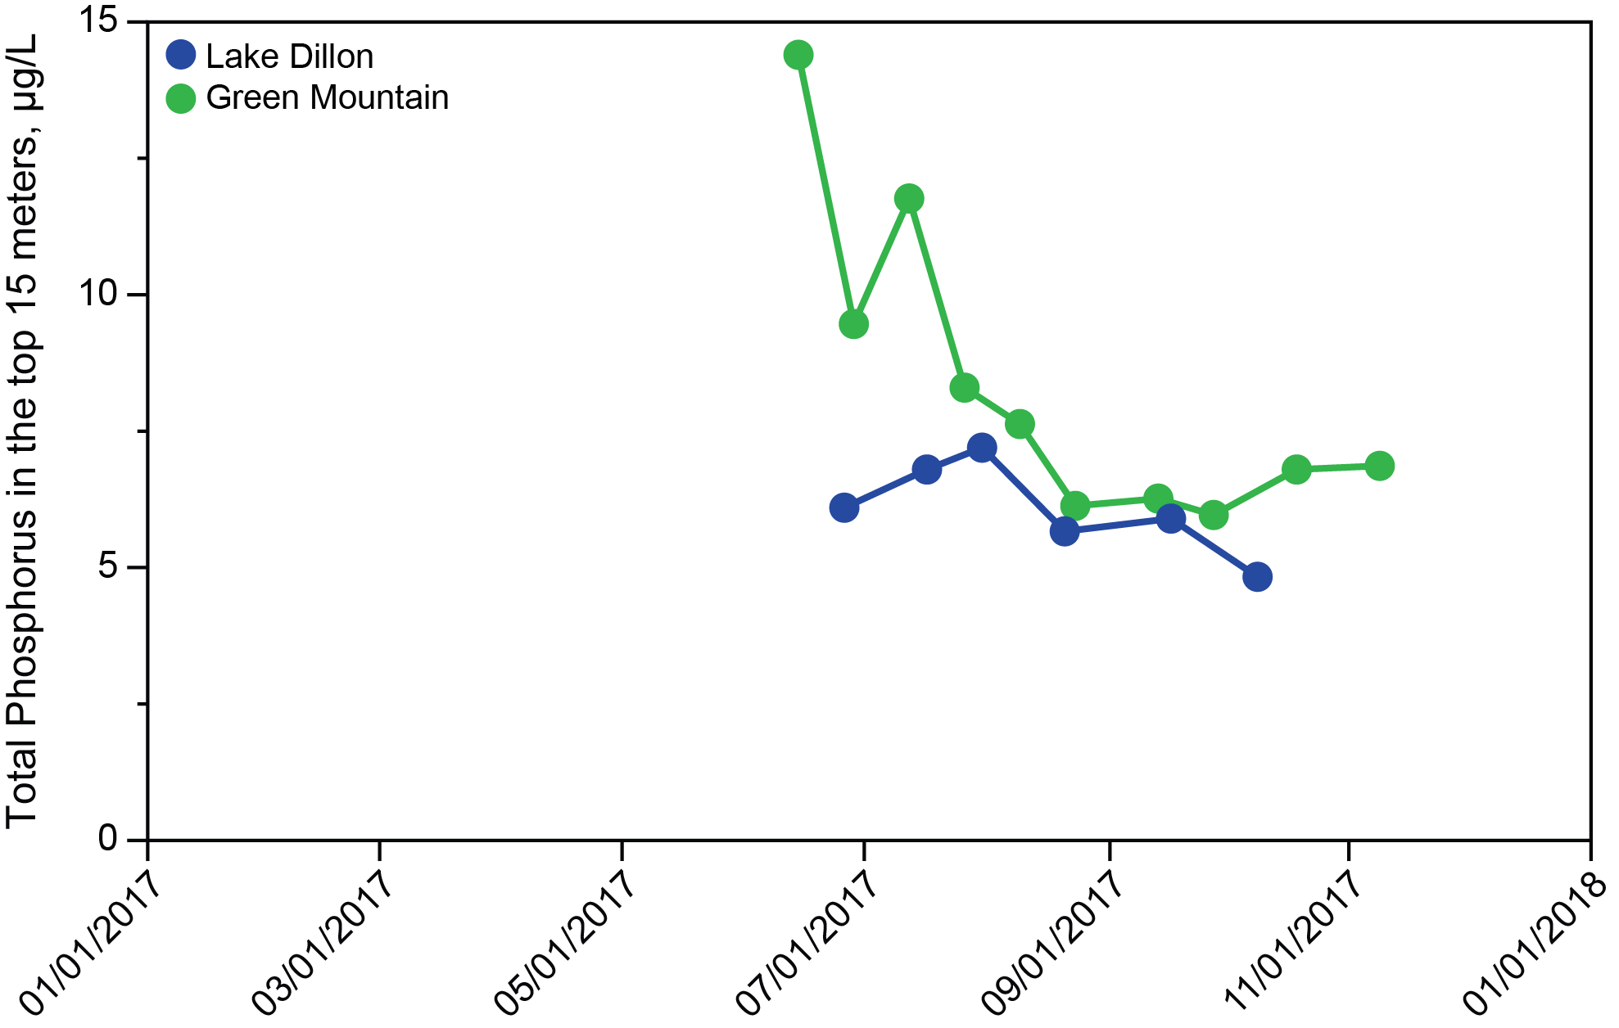

Figure 4. Concentrations of total phosphorus, 2017.

Between 1 July and 31 October (the growing season), the mean concentration of total phosphorus in the top 15 m of Lake Dillon was 6.1 µg/L (Table 9). The standard for Lake Dillon is 7.1 µg/L. The growing season mean for Green Mountain Reservoir was 7.5 µg/L (Table 10). Green Mountain Reservoir does not presently have a phosphorus standard; the proposed State standard is either 20 or 8 µg/L, yet to be determined.

Year | Total P, Growing Season | Total P in top 15m, μg/L May-June | Chlorophyll, Growing Season, μg/L | Chlorophyll a, μg/L July-August** | Secchi Depth, m
1981 | 6.8 | 7.7 | 7.5 |  | 2.8
1982 | 7.8 | 12.7 | 8.1 | 14.4 | 1.9
1983
1984 | 5.9 | 9.2 | 3.8 | 4.8 | 2.9
1985 | 7.4 | 7.8 | 3.6 | 3.5 | 3.1
1986 | 6.1 | 6.6 | 3.3 | 2.6 | 3.5
1987 | 5.4 | 6.2 | 5.5 | 3.8 | 2.9
1988 | 6.2 | 6.8 | 7 | 4.5 | 2.4
1989 | 5.9 | 5.9 | 4.6 | 3.3 | 2.8
1990 | 6.2 | 6.6 | 5.2 | 5.8 | 3.1
1991 | 7.0 | 7.2 | 4.9 | 5.1 | 3.0
1992 | 6.5 | 6.2 | 5.9 | 5.7 | 3.2
1993 | 6.1 | 7.3 | 4.9 | 4.2 | 3.3
1994 | 5.8 | 6.2 | 4.6 | 6.0 | 3.6
1995 | 6.1 | 9.3 | 5.5 | 5.9 | 2.3
1996* | 6.1 | 8.0 | 5.6 | 5.9
1997 | 6.5 | 8.8 | 4.4 | 4.2 | 3.2
1998* | 7.0 | 6.0 | 3.5 | 3.0 | 3.6
1999 | 5.8 | 6.8 | 3.8 | 3.7 | 3.5
2000* | 6.2 | 6.4 | 2.9 | 2.7 | 3.9
2001 | 5.7 | 7.9 | 2.7 | 2.8 | 4.4
2002** | 8.5 | 6.5 | 6.0 | 6.1 | 2.2
2003 | 7.0 | 11.3 | 2.5 | 3.3 | 2.8
2004** | 8.4 | 7.9 | 2.1 | 3.3*** | 4.0
2005 | 5.5 | 6.7 | 5.8 | 4.3 | 3.4
2006 | 5.4 | 6.0 | 2.3 | 2.1 | 3.6
2007** | 5.4 | 6.4 | 2.9 | 2.9 | 3.9
2008 | 5.4 | 5.9 | 3.8 | 3.4 | 3.3
2009** | 4.9 | 6.4 | 3.0 | 3.0 | 3.6
2010 | 5.2 | 6.8 | 3.4 | 2.9 | 3.9
2011** | 5.6 | 11.1 | 3.8 | 3.8 | 3.4
2012 | 7.0 | 8.6 | 3.5 | 3.5 | 4.3
2013** | 6.4 | 12.1 | 2.1 | 2.1 | 5.1
2014 | 6.3 | 8.9 | 3.5 | 4.2 | 3.1
2015** | 6.1 | 6.9 | 2.8 | 2.5 | 2.8
2016 | 6.0 | 6.7 | 3.4 | 3.5 | 3.6
2017** | 6.1 | 6.1 | 3.3 | 3.9 | 3.1
* Chlorophyll concentration applies to the part of the growing season in which the mixed layer is stable and relatively thin (July-August, 0-5 m), but excluding dates showing nitrate depletion.
** Years with greater uncertainty due to reduced sampling frequency (6/y instead of 15/y). Growing season = July – October.
*** Substituted 5 meter chlorophyll value for surface value to complete calculation.

Table 9. Interyear comparisons for trophic status indicators, Lake Dillon. Secchi depth is the average for July and August.

Year | Total P, μg/L, 0-15m | Chlorophyll a, μg/L, 0-5m | Secchi Depth, m
1984 | 8.3 | 2.3 | 3.1
1985 | 10.2 | 2.0 | 3.3
1986 | 10 | 2.8 | 3.5
1987 | 8.2 | 4.6 | 3.2
1988 | 8.9 | 2.8 | 3.3
1989 | 8.0 | 2.3 | 3.3
1990 | 9.6 | 2.4 | 2.5
1991 | 10.5 | 4.1 | 3.2
1992 | 8.7 | 9.3 | 2.3
1993 | 9.0 | 3.6 | 3.4
1994
1995
1996 | 7.6 | 2.7 | 4.1
1997 | 8.0 | 2.5 | 3.6
1998
1999 | 7.4 | 2.2 | 4.5
2000
2001 | 7.9 | 1.3 | 2.7
2002
2003
2004
2005 | 8.7 | 2.7 | 3.1
2006
2007 | 8.5 | 2.4 | 4.0
2008
2009 | 8.3 | 1.5 | 4.0
2010
2011 | 8.2 | 1.8 | 3.3
2012
2013 | 10.1 | 1.3 | 2.9
2014
2015 | 7.1 | 2.8 | 3.9
2016
2017 | 7.5 | 1.0 | 3.5

Table 10. Interyear comparisons for trophic status indicators, Green Mountain Reservoir (growing season, July – October). Secchi depth is the average for July and August.

Nitrate
The concentrations of nitrate in the two lakes were high during spring (Figure 5). Nitrate was never completely depleted during 2017 in either Green Mountain Reservoir or Lake Dillon (some years in the past have shown complete depletion). Concentration of nitrate rebounded as soon as the mixed layer began to thicken in October.
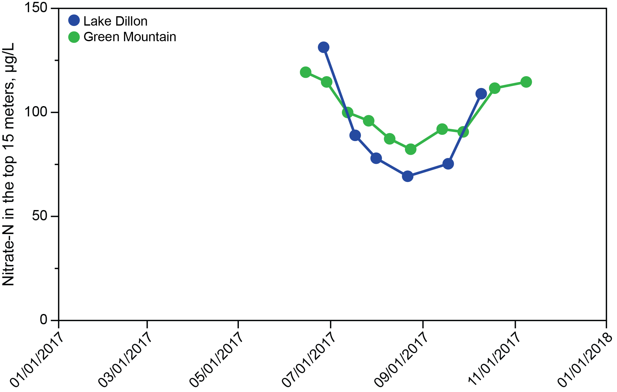
Figure 5. Concentrations of nitrate, 2017.

Chlorophyll
Concentrations of chlorophyll a were much lower in Green Mountain Reservoir than in Lake Dillon for all months except June, when the two were nearly equal. Green Mountain Reservoir showed consistent suppression of phytoplankton biomass because of low hydraulic residence time. When outflow was cut in late fall 2015, biomass increased, but in 2017 the reduction in flow came after the last samples were taken (Figure 7).
Peak concentrations of chlorophyll in Lake Dillon during the growing season until September were ~5.5 µg/L (Figure 6, no winter sampling for Dillon). In many past years, the peak has been higher. Flushing of the upper water column (spillway overflow) was probably responsible for suppression of algal accumulation in 2017.
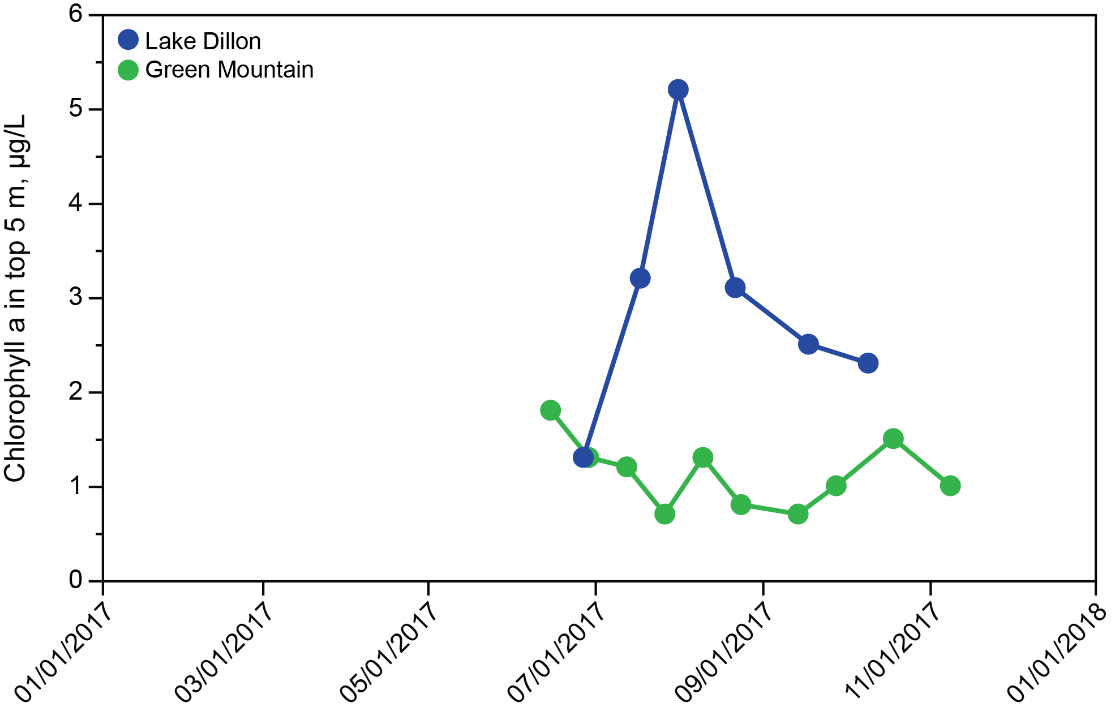
Figure 6. Concentrations of chlorophyll, 2017.

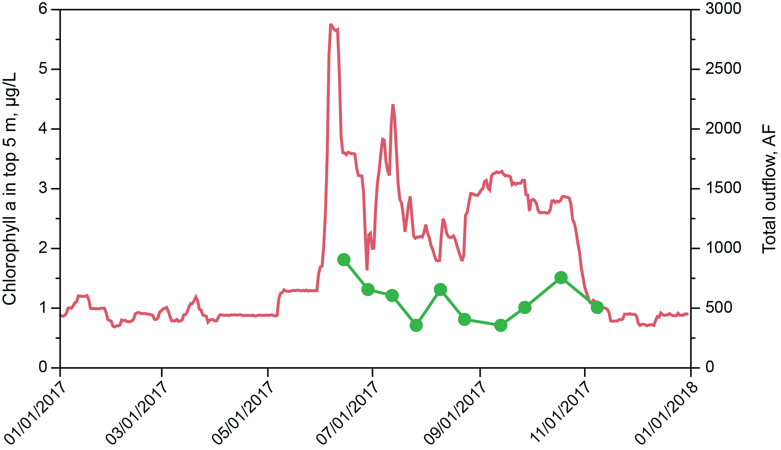

Figure 7. Influence of outflow on algal accumulation, 2017.

Mass Transport of Phosphorus
As part of the monitoring for 2017, concentrations of phosphorus and concurrent information on discharge are available for Straight Creek, water flowing through the dam at Lake Dillon, and two locations on the Blue River between Lake Dillon and Green Mountain Reservoir, as well as the Green Mountain Reservoir outflow and the Silverthorne/Dillon effluent. The discharge and total phosphorus data are as shown in Tables 11 and 12.
For 2017, the total phosphorus flowing into Green Mountain Reservoir was approximately 8,477 kg for the year. The sources of this phosphorus are as follows: Straight Creek, 4.4%; Silverthorne/Dillon effluent, 3.8%; Lake Dillon, 13.7%; and the Blue River drainage between Lake Dillon and Green Mountain Reservoir 78.1%. The sedimentation loss for phosphorus in Green Mountain Reservoir for 2017 was close to 50.1%, which is within the normal range for this reservoir.
Total phosphorus concentration for water flowing into Green Mountain Reservoir (from Table 11) was 10.5 µg/L, which was double the discharge concentration exiting Lake Dillon (4.8 µg/L). Concentrations for Straight Creek were higher than concentration for water exiting Lake Dillon, as expected, but lower than for waters originating from the watershed tributaries and direct runoff between the two reservoirs.

Flow, cfs
 | 19-  Jan | 16-  Feb | 9-  Mar | 13-  Apr | 11-  May | 25-  May | 15-  Jun | 29-  Jun | 13-  Jul | 27-  Jul | 10-  Aug | 24-  Aug | 14-  Sep | 28-  Sep | 19-  Oct | 9-  Nov | 7-  Dec
BR1 | 98.1 | 98.1 | 81.3 | 98.1 | 199.0 | 207.0 | 1090.0 | 387.0 | 412.0 | 199.0 | 294.0 | 116.0 | 98.1 | 98.1 | 95.0 | 107.0 | 110.0
STL |  |  |  | 9.9 | 23.7 | 37.1 | 126.1 | 98.0 | 63.8 | 27.5 | 19.6 | 13.4 | 9.5 | 9.9 | 7.0 | 3.3
SDE | 1.1 | 1.3 | 1.3 | 1.8 | 1.5 | 2.1 | 1.6 | 1.6 | 1.7 | 1.5 | 1.4 | 1.2 | 1.1 | 1.0 | 1.0 | 1.0 | 1.0
BR3 |  | 161.0 | 128.0 | 264.0 | 511.0 | 717.0 | 3800.0 | 1240.0 | 1160.0 | 625.0 | 569.0 | 248.0 | 197.0 | 161.0 | 183.0 | 161.0 | 160.0
BR4 | 240.0 | 223.0 | 188.0 | 203.0 | 329.0 | 324.0 | 898.0 | 461.0 | 988.0 | 565.0 | 564.0 | 695.0 | 795.0 | 704.0 | 698.0 | 352.0 | 231.0
BR6 | 118.0 | 118.0 | 104.0 | 150.0 | 285.0 | 318.0 | 1670.0 | 657.0 | 569.0 | 293.0 | 346.0 | 139.0 | 116.0 | 118.0 | 116.0 | 126.0 | 129.0
TP, ug/L
 | 19-  Jan | 16-  Feb | 9-  Mar | 13-  Apr | 11-  May | 25-  May | 15-  Jun | 29-  Jun | 13-  Jul | 27-  Jul | 10-  Aug | 24-  Aug | 14-  Sep | 28-  Sep | 19-  Oct | 9-  Nov | 7-  Dec
BR1 | 5.1 | 4.3 | 4.0 | 4.3 | 4.3 | 4.7 | 5.3 | 6.3 | 6.7 | 6.2 | 5.3 | 4.0 | 3.5 | 3.5 | 4.6 | 4.7 | 4.0
STL | 5.2 | 7.0 | 5.9 | 90.7 | 11.0 | 8.9 | 9.7 | 6.6 | 9.3 | 8.5 | 7.5 | 11.2 | 12.6 | 10.2 | 12.9 | 20.2 | 4.1
SDE | 531.3 | 334.7 | 121.8 | 12.9 | 28.1 | 11.9 | 112.6 | 308.7 | 264.9 | 747.4 | 500.5 | 599.8 | 201.9 | 125.3 | 44.9 | 28.4 | 80.9
BR3 | 9.3 | 10.2 | 6.7 | 13.0 | 21.0 | 21.6 | 11.9 | 15.8 | 19.5 | 7.7 | 9.0 | 6.6 | 5.6 | 4.7 | 5.4 | 4.6 | 6.1
BR4 | 5.5 | 5.9 | 6.7 | 5.5 | 7.1 | 6.6 | 10.7 | 7.3 | 13.8 | 7.3 | 8.9 | 9.0 | 7.9 | 6.7 | 7.3 | 6.5 | 8.1
BR6 | 14.5 | 9.5 | 6.8 | 6.9 | 8.3 | 8.9 | 5.9 | 10.9 | 8.8 | 10.5 | 8.1 | 10.9 | 6.4 | 6.6 | 4.5 | 4.5 | 4.9

Table 11. Summary of data used to calculate mass balance, 2017.

Total Phosphorus, kg/y
BR1 | Blue River at outlet from Dillon Reservoir. | 1165
STL | Straight Creek at confluence with Blue River | 373
SDE | Silverthorne/Dillon effluent | 319
BR3 | Blue River at the inlet to Green Mountain Reservoir | 8477
BR4 | Blue River at outlet from Green Mountain Reservoir | 4229
BR6 | Blue River below Silverthorne, upstream from Bushee Creek. | 2495

Table 12. Annual total P load at sampling points, 2017.

Total N
Total N was added to the list of analytes in 2011 in response to the State’s proposal to limit total N (proposed limit for coldwater lakes, 426 µg/L; streams, 1250 µg/L, growing season mean). Lake Dillon was well below the proposed lake standard; Green Mountain Reservoir was nearer to but not above the proposed lake standard. Figure 8 shows the results.
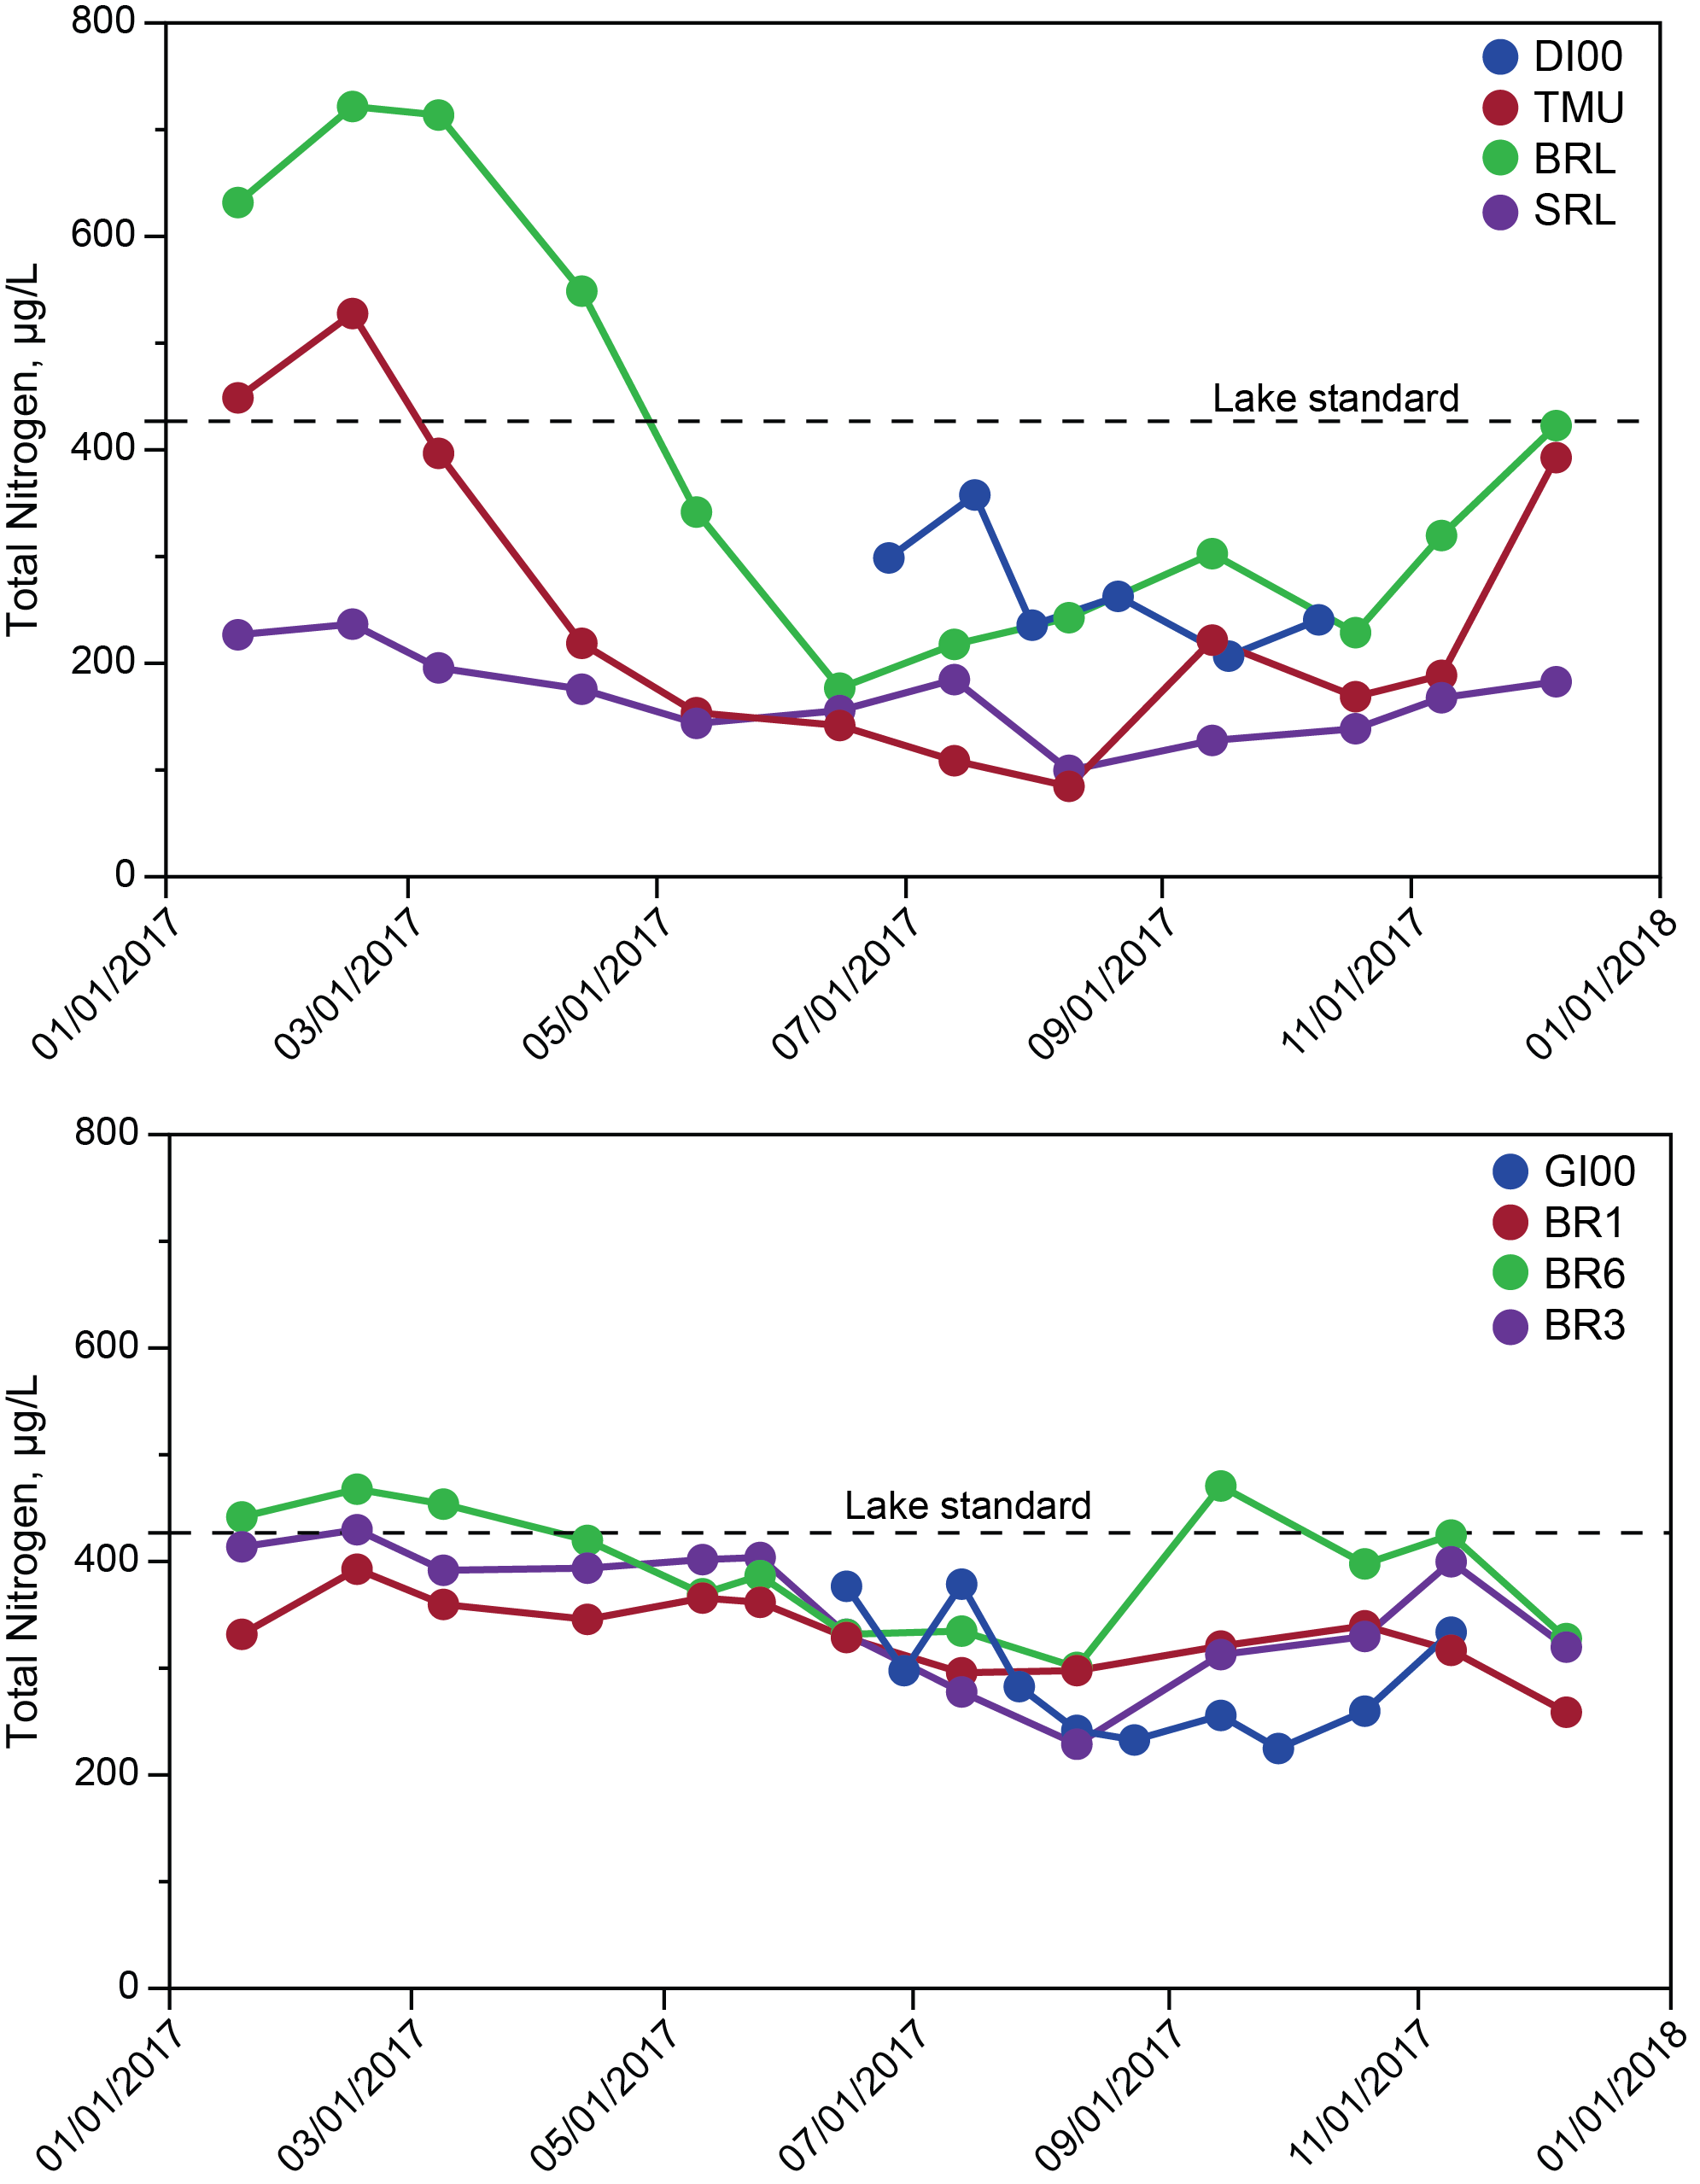
Figure 8. Total N during 2017. Dashed lines indicate coldwater standard for lakes; the stream standard is off scale (1250 µg/L).
Nitrate, a substantial component of total N, has received special attention in recent years because of a long term upward trend in nitrate concentrations for Lake Dillon. Wastewater treatment plant operators within the watershed have speculated that the upward trend would level off because of improvements in nitrate removal within wastewater treatment facilities. The sources of nitrate behind the increase of nitrate in the lake have not been quantified. They would certainly include wastewater treatment facilities and septic systems. Reduction of the municipal facility source would affect the total, of course.

Conclusions
Year 2017 was near to average in runoff, and produced moderate spillway overflow for Lake Dillon. Phosphorus and chlorophyll concentrations in Lake Dillon and Green Mountain Reservoir were in the midrange of values observed over recent years.

Appendix I.
Water Quality Data for 2017

